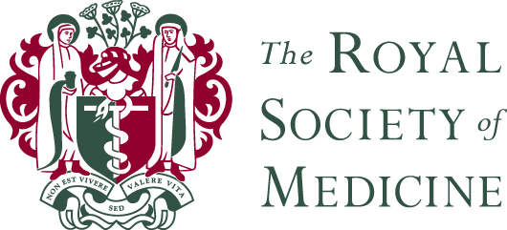

**People and Wellbeing Advisor**

**Job Description**

Full Time Permanent

A mixture of office (central London) and home working is anticipated with this role.

The Royal Society of Medicine is one of the UK’s leading providers of continuing learning in healthcare. Our vision is ‘better healthcare for better lives’. We aim to achieve this by sharing learning and supporting innovation on the science, practice and organisation of medicine.

As a registered charity and membership organisation with a global network of 20,000 members, we bring together healthcare professionals across specialties. We offer a range of membership options for every career stage, from students to retirement.

We deliver multidisciplinary, specialist and general education, as well as professional development, drawing on the support of leading experts in over 50 specialist areas of medicine.

Our learning resources span a wide collection of books, journals, digital journals and online medical databases. We are home to one of the finest physical and digital medical libraries in the world. We connect those involved and interested in healthcare and, by leveraging expertise from across the RSM, we support, help and inspire the innovators developing the medical products and services of tomorrow.

**Overall Job Purpose**

In this role you will work closely with the Head of People and Wellbeing to provide support in a varied generalist role, responsible for providing proactive, professional, and business focused HR support to our operational leaders and managers.

**Key tasks & responsibilities**

* Proactively advising and supporting managers around employee relations casework advice and guidance; supporting disciplinary, grievance, performance management and sickness absence processes.
* Identifying and escalating high risk issues to the Head of team and key stakeholders.
* Supporting managers to develop and increase their management confidence and ability and consistency of approach to case handling.
* Support change management, including TUPE and restructures.
* Support with People and Wellbeing policy development including managers toolkits.
* Analysis of ER data, providing business insights and trend analysis.
* Delivery of HR related training to managers.
* Work with managers across the business on L&D requirements and ensure the best use of partner platform (Udemy) to deliver on development needs.
* Support to undertake people projects that are aligned to the RSM’s strategic priorities.
* Take an active role in EDI and wellbeing activities in line with the overall People and Wellbeing strategy.
* Work across the team to ensure operational excellence is maintained (to include payroll updating checking).

**Person Specification**

You will have previous experience in a similar role and / or a proven track record of operational HR and sound knowledge and understanding of UK employment law – likely to have been developed through a programme of study.

Experience of setting up and managing ER meetings, taking appropriate notes and providing on the spot advice is essential. The responsibility for writing outcome letters, as well as succinct reports and recommendation papers also lies with this role and excellent written and verbal skills are therefore required.

You will have strong organisational and problem-solving skills, be solution focused and be able to develop and maintain strong and collaborative working relationships at all levels to ensure we understand and act in the best interest of the needs and priorities of our stakeholders.

You should be able to demonstrate an interest in learning and development as this is a key area of contact across the business for the post holder.

You will be familiar with HR systems and processes and be keen to develop your own skills and knowledge as an HR professional.

**The post holder must always when conducting responsibilities and interacting with others:**

* Uphold the vision, mission and values of the RSM
* Support effective communication and consistent management of RSM policies and procedures throughout the organisation
* Adhere to the Society’s Health and Safety regulations and ensure the safety of oneself and others engaged in the RSM premises and work by reporting hazards to a senior manager for address or taking actions (where possible) to remove safety hazards
* Adhere to the Society’s Data Protection regulations and only use data as required to undertake their role and handle it in an appropriate and confidential manner
* Fully subscribe to the spirit of and adhere to the Society’s people policies in particular the Discrimination, Bullying, Harassment, Victimisation policies.